* **# of Teams:**

32 of which from Division I conferences with [automatic bids](https://en.wikipedia.org/wiki/Automatic_bid)

68 teams

36 of which are from “[at-large](https://en.wikipedia.org/wiki/Wild_card_(sports)#College_basketball)” berth (i.e. ,not win the conference tournaments, but selected by Selection Committee)[1]

* **Rule:**

Single-elimination: The loser of each match-up is immediately eliminated from the tournament

* **Seeding Rules:**

1. Rank all 68 teams from 1-68
2. Divide the teams amongst regions (4 regions, say, W, X, Y, Z ):

1-4: Seed 1 in W, X, Y, Z

5-8: Seed 2 in W, X, Y, Z

…

1. Additional rules affects seeding (original seeding maybe adjusted):
2. First four selection (see next “First Four Play-in Games) - > Each region has 16 teams
3. Teams from the same conference cannot meet until the regional finals
4. Avoid any possible rematches of regular-season or previous year’s tournament games during the First and Second rounds, for example:

*the 40th overall ranked team, originally slated to be a No. 10 seed within a particular region, may instead be moved up to a No. 9 seed or moved down to a No. 11 seed*

**Thus,** the bracket (see the example snapshot below) is established, and during the semifinals, the champion of the top-ranked number 1 seed's region will play against the champion of the fourth-ranked number 1 seed's region, and the champion of the second-ranked number 1 seed's region will play against the champion of the third-ranked number 1 seed's region

* **Venues (关于场地)：**

In the men’s basketball, all sites are nominally neutral! Teams are prohibited from playing tournament games on their home courts prior to the Final Four

* **Rounds**

1. **First Four Play-in Games**

This started since 2011. The games are contested between teams holding the four lowest seeded automatic bids (thoses 4 teams are competed to receive No.16 seeds) and the four lowest seeded at-large bids (the 4 teams are competed to receive No.11 seeds).

Example of 2019 Brackets

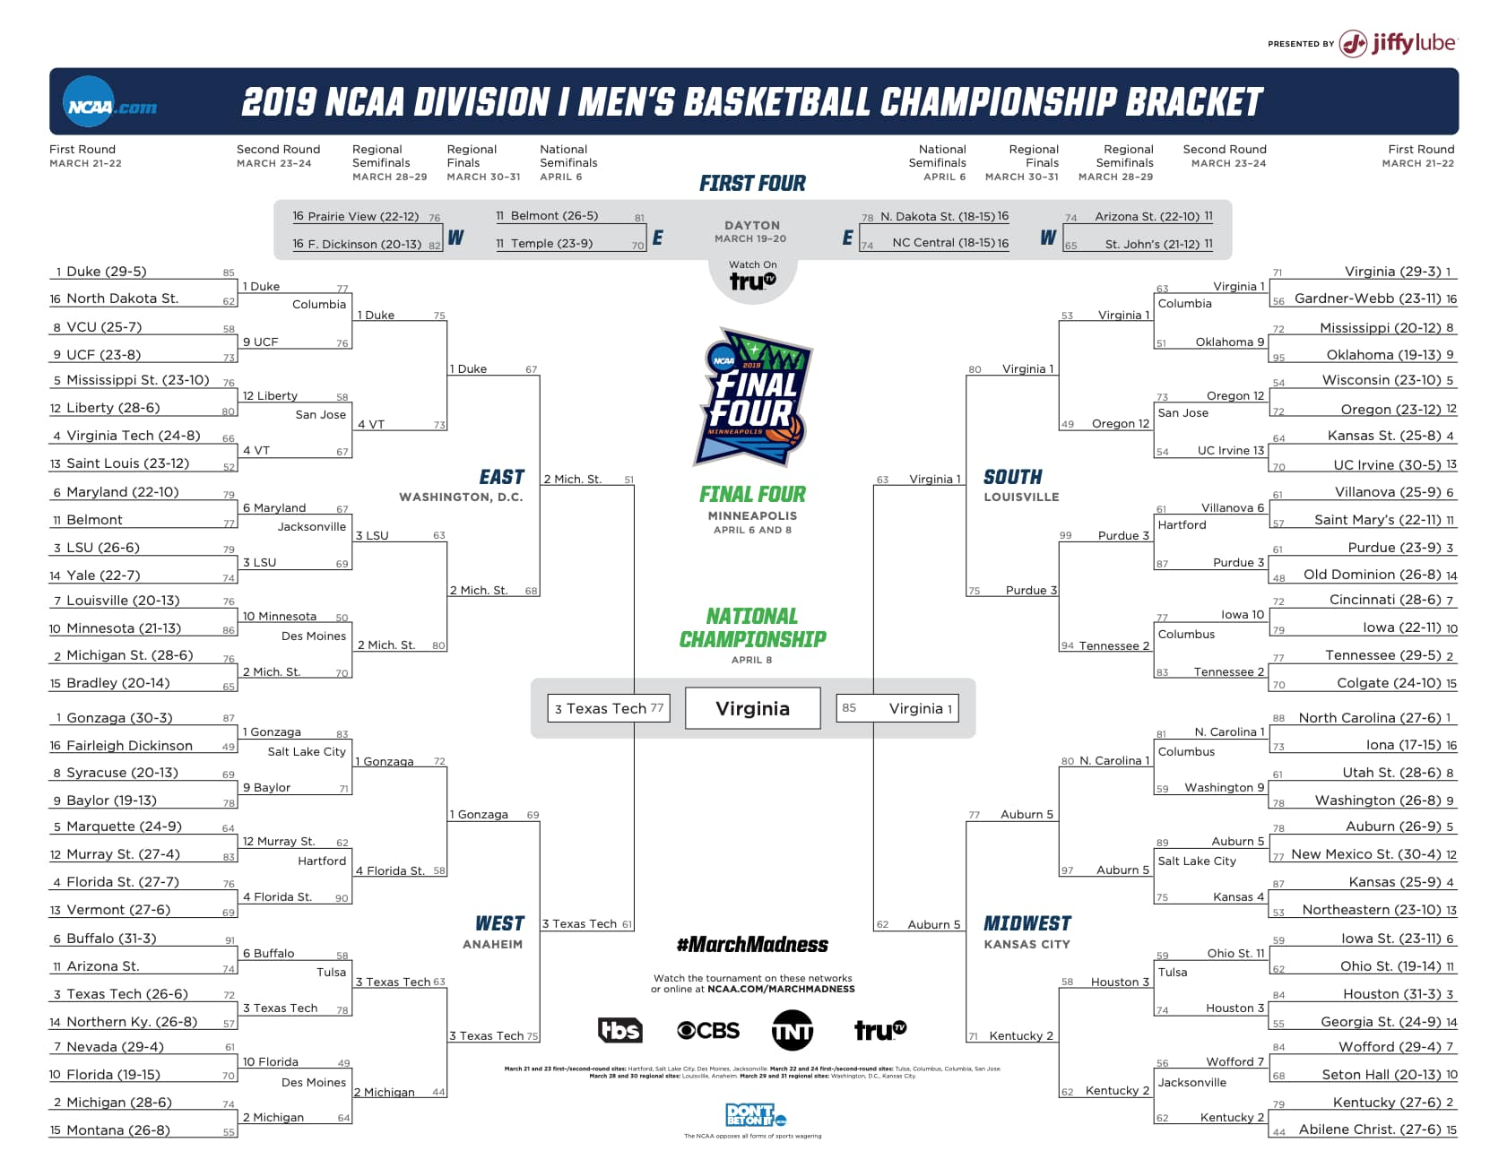

1. **First and Second Round**
2. First Round:

Within each region, the seeds competed:

Left 32 teams

|  |  |
| --- | --- |
| Seed 1 | Seed 16 |
| Seed 2 | Seed 15 |
| Seed 3 | Seed 14 |
| Seed 4 | Seed 13 |
| Seed 5 | Seed 12 |
| Seed 6 | Seed 11 |
| Seed 7 | Seed 10 |
| Seed 8 | Seed 9 |

1. Second Round:

Played immediately after the first round

1. Regional semifinals and finals
2. Final Four

Which regional champion will play which, and in which semifinal they play, is determined by the overall rankings of the four No. 1 seeds in the original bracket, not on the ranks of the eventual Final Four teams themselves.